The Catcher in the Rye Essay Assignment

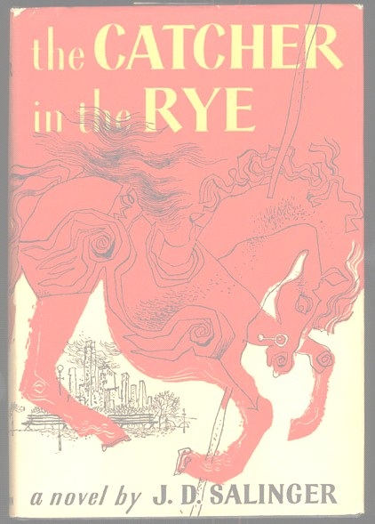
Write an analytic essay on one of the following topics:

- Holden is clearly a young person on the brink of becoming an adult who is anxious about the transition into adulthood. Why do you think he is so unwilling to make the plunge? You may decide that there are several reasons for his distaste for adulthood or you may argue for one overriding cause. Whichever you decide, you must prove your assertion with at least three paragraphs of references to events and reactions to those events, of quotations and discussions of those quotations.

- Salinger creates a clear value system in The Catcher in the Rye; Holden focuses on these virtues and vices throughout the novel. What do you think Holden feels are the major evils in the world and what would he like to do about them? How does his concern about the evils of the world affect him? Again, at least three major points must be cited, discussed, and illustrated with references to and quotations from the novel to support your assertions.

- We discussed Holden’s idealistic nature and its effect on him. How do the conflicts in the novel relate to his idealism? How do his experiences and the people that he encounters challenge those ideals? Can Holden “hold on” to his ideals and still function in society? Why or why not? Focus on specific examples of idealism and disillusionment in your essay.

- Explore Holden’s unreliable narration by showing how Holden is not as mature or sophisticated as he would like people to believe. Be sure to incorporate the text thoroughly into your essay, exploring the discrepancies between his “image” and the “real” Holden behind that image.

- Choose one of the themes that we discussed in class and demonstrate how it applies to Holden’s struggle. You should use the text to support your ideas and might want to discuss significant symbols or motifs to underscore your assertions.

* * * * *

Your paper should be a standard five paragraph essay, containing an introductory or thesis paragraph, a body (three paragraphs), and a concluding paragraph. Each body paragraph should begin with a strong topic sentence (introducing the paragraph and connecting it to the thesis statement) and contain direct quotes from the text to support points (must be formatted correctly).Your concluding paragraph should summarize the points that you have made in proving your thesis and explicitly state the conclusions that you have drawn. It should also contain new knowledge and understanding. Be sure to proofread carefully.

You may not consult or incorporate outside sources when writing this paper.

Length and format: Your paper should be at least 3 word-processed pages (12 point New Times Roman font, double spaced, with 1 inch margins). See The Pingry Manual of Style for guidelines on the physical format for your paper. Remember to give your paper a title. Email your paper to mdantoni@pingry.org on or before the due date.

Due dates:

Introductory paragraph and topic sentences (typed)
Final draft (see formatting guidelines above)

