The Odyssey

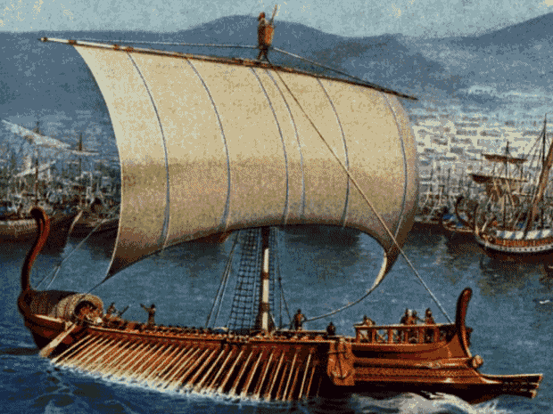 | “Odyssey” is a familiar English word,
 | meaning, according to Webster, “a series
 | of adventurous journeys usually marked
 | by many changes of fortune.” The Greek
 | word Odusseai, the form from which the
 | English word is derived, simply means,
 | “the story of Odysseus,” a Greek hero of
 | the Trojan War who took ten years to
 | find his way back from Troy to his home
 | on the island of Ithaca, off the western
coast of mainland Greece. Homer’s | Odyssey does indeed present us with
“adventurous journeys” and "changes of | “ fortune,” but it is also an epic tale of a
hero’s return, to find at home a | situation more dangerous than anything
he faced on the plains of Troy or | in his wanderings over uncharted seas.

The Greek Philosopher Aristotle, writing in the fourth century B.C., gives us, in his treatise known as the Poetics, what he considers the essence of the plot. “A certain man has been abroad many years; he is alone, and the god Poseidon keeps a hostile eye on him. At home the situation is that suitors for his wife’s hand are draining his resources and plotting to kill his son.” This is an epic tale of his struggle to get home and in the process, he suffers a storm and a shipwreck, he faces powerful gods, and he confronts mythical creatures.

This 12,109 lines of hexameter verse, composed probably in the late eighth century or early in the seventh B.C., by a poet known to the later ages as Homer, for whose life and activities no trustworthy information has come down to us. Essentially, the poem is about 2,700 years old.

Theories about Homer…

●Homer was a blind Greek poet who wandered from town to town chanting his poetry to the accompaniment of a lyre. Authorities do not exactly agree when Homer lived. Dates vary anywhere from 1100’s-600’s B.C.

● While it is widely believed that Homer is the author of both The Illiad and The Odyssey, some say that these works were not written by one particular person, but are instead of collection of Greek poems.

● One of the interesting and unique things about The Odyssey is that it was originally communicated orally. The ancient world began copying the epic poem by hand in the latter part of the sixth century B.C., and the twenty-four books coincide with the twenty-four scrolls that were filled with the incredible journey.

The Odyssey is an Epic Poem: a narrative poem that tells in an elevated style the achievements and brave deeds of heroic characters. Miraculous events and supernatural beings often play a part.

The characteristics of an Epic:
1. The hero is a figure of national importance.
2. The action involves a long and dangerous journey.
3. The setting of an epic is large in scale.
4. Supernatural beings and events play a role in epic affairs.
5. The style of the of an epic is formal and grand.
6. Epics assign short phrases to individual characters.
7. Epics usually contain twenty-four books or parts.

More specifically, it is a Folk Epic because it is a narrative is based on heroic legends.

Some words to know…

Simile: A comparison between two unlike things, using a word of comparison such as “like” or “as.” “And out he stalked/as a mountain lion exultant in his power” (172).

Epithet: An adjective or descriptive term that points out some trait of that person or thing being considered. “The bright-eyed goddess sped away to Olympus…” (169).

Repetition: Repeating words or phrases for emphasis or for retention in memory.

Remember that this particular piece of literature has oral origins and therefore these devices would have been helpful for the storyteller and the audience.

Features that make Homer’s poetry classic are:

● Simplicity of language
● Swift movement of narrative
● Creation of characters with uncomplicated motives
● Actions that are true to human nature
● Plots that blend the joys of living with the tragic sense of life
● Long, musical lines
English 9 YORKE

Introduction: The Odyssey

1. What does “Odyssey” mean? What does “Odusseai” mean?

2. What literary genre is The Odyssey? How many lines is it? What meter is it written in?
How old do scholars suggest it is?

3. Who supposedly write The Odyssey? What else did he write? What is something interesting about this epic tale? What is the significance of 24?

4. What is an epic poem? What is a folk epic?

5. What are the characteristics of an epic poem?

6. What is an epithet – try to give an example. What are some of the other literary devices that Homer uses in The Odyssey? Why are these devices particularly significant?

7. What are some of the features that make Homer’s poetry classic?

8. What was the Trojan war about? What city did it concern? How did it get started? Who was involved? How was it won?

9. Geographically, where is Troy? Did this have any significance in the city’s power/history?

10. Looking at the Time Line: Where does Odysseus come from? How long is the Trojan war? How long does it take him to get home?

